Tlc marketing ltd  Harcourt Street London w1h 4hf

Summative Portfolio – “Gianluca Meola”

Level 3 Software Development Technician

# Contents Page

# **Introduction**

Within the introduction section you will be required to write up something with the following information.

1. **Name the company you work for, where it is based**
2. **Describe the aims and objectives of the company,**
3. **Describe the specific products and services that it offers**
4. **Describe the customer base that purchases the products / services**
5. **Describe your role in the company**
6. **Describe why you have decided to complete an apprenticeship.**
7. I work for TLC Marketing Worldwide, based in central London, close to Baker Street.
8. TLC Marketing Worldwide is a global marketing agency. The company is formed by a team of people that are a specialist marketing agency helping global brands influence consumer choice by providing on-brand rewards to every person who engages with the promotion.
9. The company provides to the client microsites where they can manage their promotional campaigns.
10. Most of the clients are international brands like Vodafone, Huggies, Time Out, etc.
11. My role in the company as a Junior .Net and full stack developer is to create a new feature for the Content Management System that the company uses to edit the microsites, and as front-end developer I create some new template microsite for new campaign.
12. From the first day that I arrived in TLC, I started to learn many new features from the seniors, I learn about technologies and methodologies that they do not teach you during the courses, and this is the advantage to start an apprenticeship because you can learn and grow as a developer while you work. I can approach to real word tasks and build good habits and strong skills.

# **Logic**

writes code following an appropriate logical approach to agreed standards (whether web, mobile or desktop applications).

**Work activities demonstrating the minimum expected level of competence (Pass)**

* Designs simple programs and program modifications from supplied specifications, using agreed standards and tools, to achieve a well-engineered result.
* Creates and amends simple programs in accordance with the design.
* Documents all work in accordance with agreed standards.
* Takes part in reviews of own work.

**Work activities demonstrating competence beyond the minimum expected (Merit/Distinction)**

* Designs moderately complex programs and program modifications from supplied specifications, using agreed standards and tools, to achieve a well-engineered result.
* Creates, amends and keeps track of moderately complex programs in accordance with the design.
* Documents all work in accordance with agreed standards.
* Takes part in reviews of own work. Takes part in reviews of the work of colleagues.

During the apprenticeship, I worked on several tasks that involve the creation of an algorithm that sort, filter, delete, add or select specific items from an array, a list or similar. One first algorithm that I wrote is in the SiteGenService, to define the pages to add in the Angular routing component during the creation of the website.

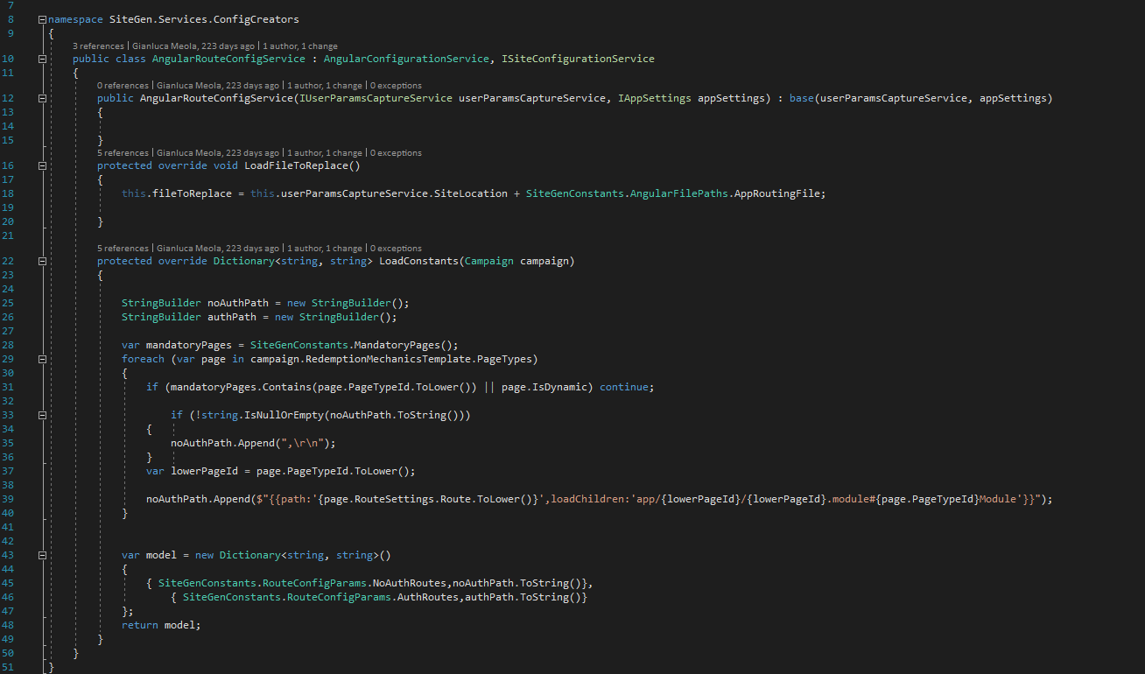

In the image below there is the for loop that check if the pages are not mandatory or dynamic. If the pages are not mandatory or dynamic, the program will append in the routing Model file of the angular application the new page name, in that way will be possible to navigate to the new component, that will be added by another part of the program.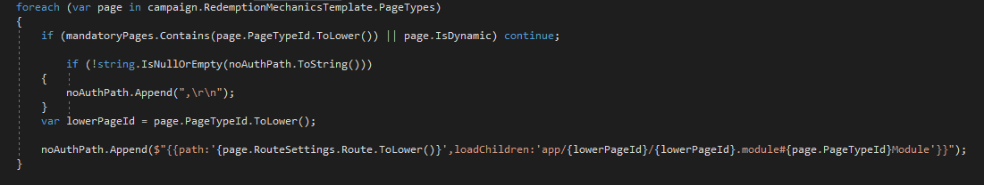

Before to append a new string in the routing module, I check if the string is null or empty to avoid error. If the string is not empty then I add the string in the list of string noAuthPath (Is a not authorization path of routing string, because some string need authorization in the website to navigate to them).

The mandatory pages are declared as a list of strings, transformed in lowercase to avoid case sensitive errors. The IsDynamic property is defined in the metadata property.

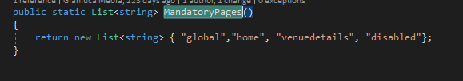

# **User Interface**

develops user interfaces as appropriate to the organisation’s development standards and the type of software development being undertaken.

**Work activities demonstrating the minimum expected level of competence (Pass)**

* Assists in the design of simple applications using templates and tools to specify user/system interfaces including, for example: menus, screen dialogues, wireframes, boned rigs, inputs, reports, validation and error correction procedures, and processing rules.
* Contributes to user interface designs including colour, language, presentation, input methods, error handling and responses.
* Documents all work using required standards, methods and tools, including prototyping tools where appropriate.
* Assists in the execution of test plans to verify accessibility and usability of completed software.

**Work activities demonstrating competence beyond the minimum expected (Merit/Distinction)**

* Designs simple applications using templates and tools to specify user/system interfaces including, for example: menus, screen dialogues, wireframes, boned rigs, inputs, reports, validation and error correction procedures, and processing rules.
* Contributes to detailed user interface designs including colour, language, presentation, input methods, error handling and responses.
* Documents all work using required standards, methods and tools, including prototyping tools where appropriate.
* Constructs, interprets and executes test plans to verify accessibility and usability of completed software.

For the user interface project, I will show you one of the most popular and well looking templates that we have at Tlc Marketing to create the campaign.

The design is easy to use and fast.

The exterior design has been created by our senior front-end developer for a USA campaign about the fitness.

However, the source code couldn’t be for other campaign because it was a stand-alone campaign. Then what I have done in 2 weeks is design a template that could be used for different campaign, and the clients could have full control of the content from the Admin Portal Content Management System.

What you see in the images are component that create dynamically the content (images, text or videos) if those content have been submitted from the Admin Portal.

Everything is injected from the Content Management System.

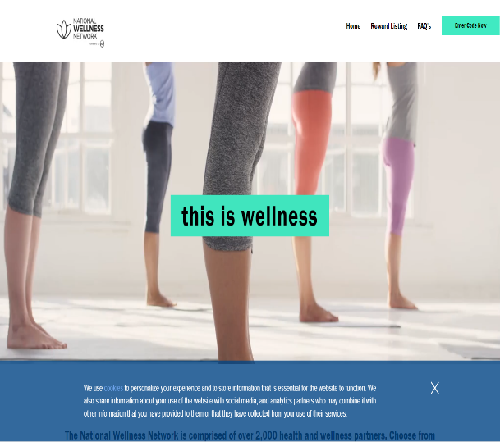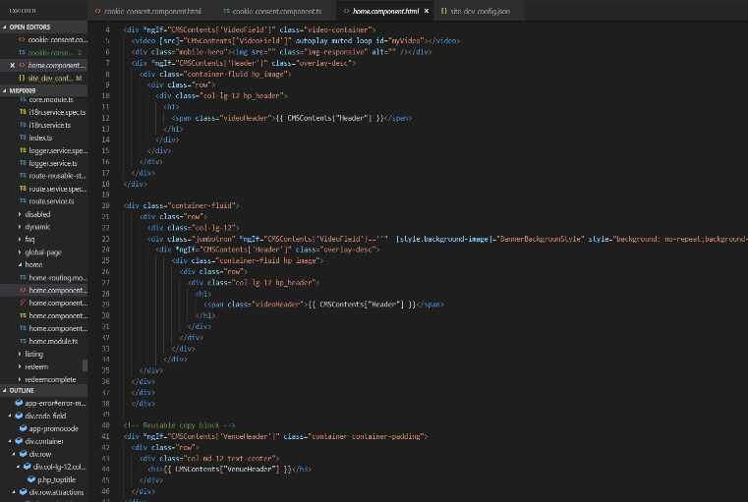

That is the metadata data file that I designed and created to display and get the values from the Admin Portal of the content manager System. This file will be edited every time that the customer will want from admin portal and trough a call to the CMS micro service.

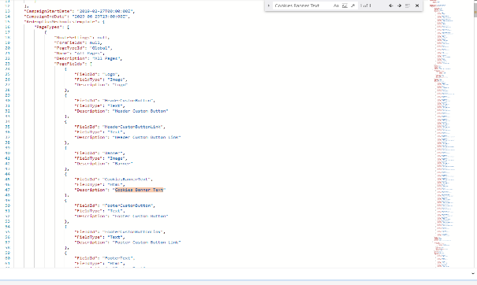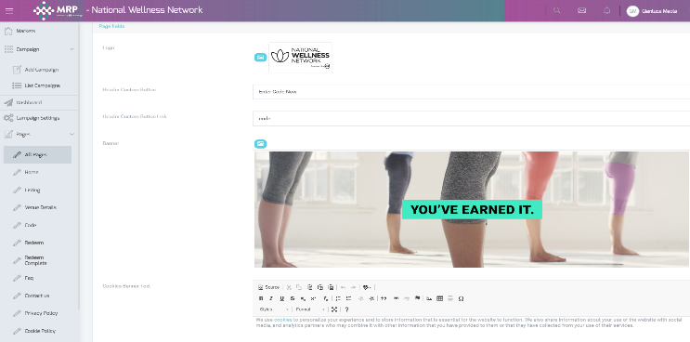

The same for the Listing page where I created a completely new layout and I add some animation with plain CSS.

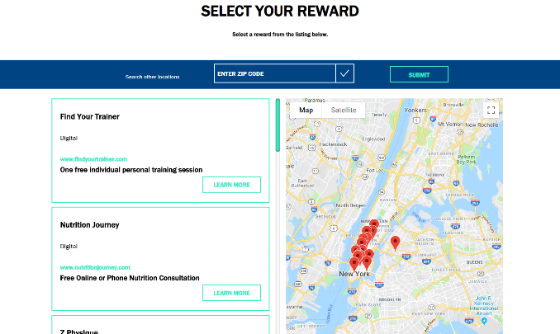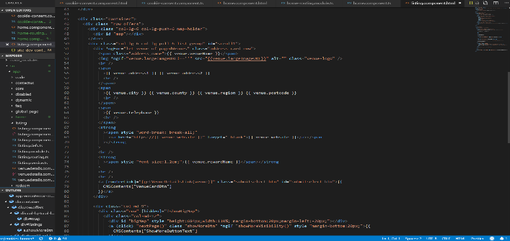

This is the redemption form where I had the dynamic validation and fields from the Admin Portal.

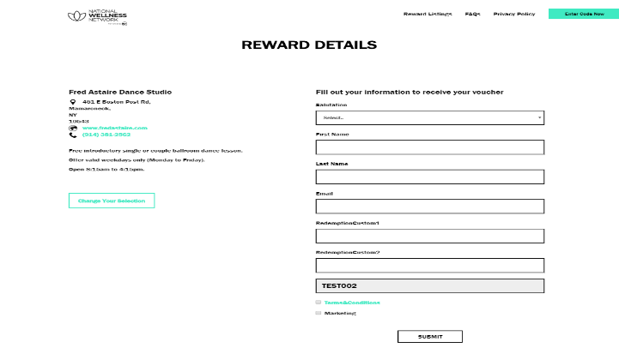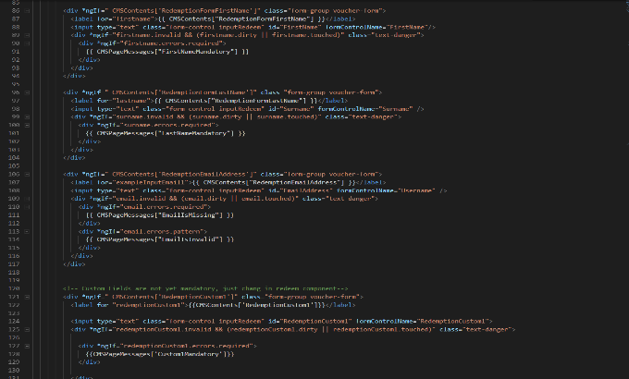

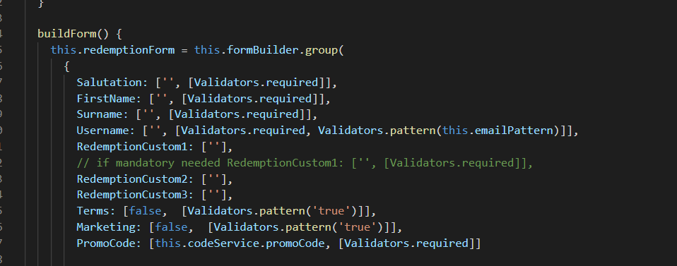 Here there are some of the fields that are mandatory for some campaign and the email field has a regex to validate the email. 

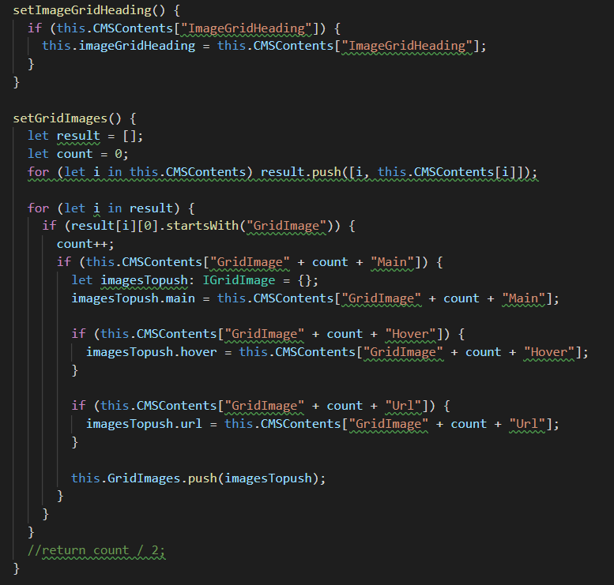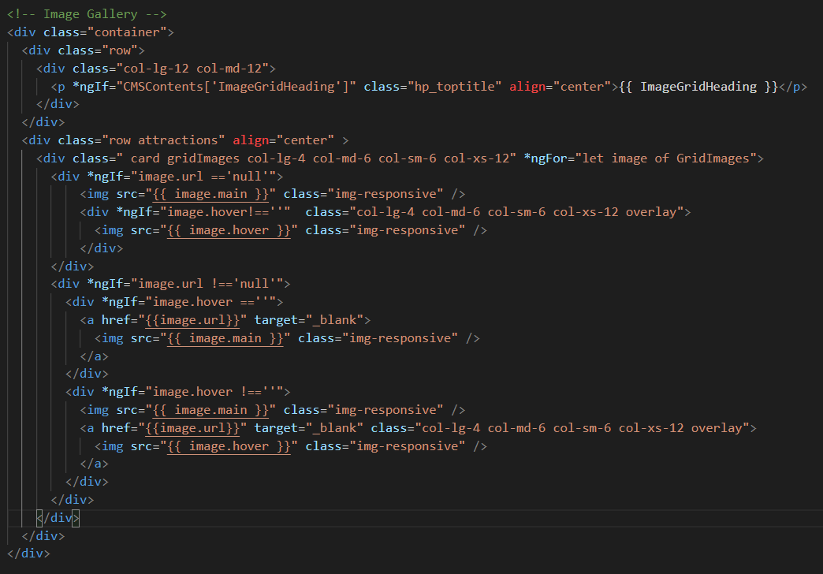

Here in the Image Gallery I build it in a dynamic way, so the client is not forced to upload 9 images or upload 9 Hover image or even they have the option for each image to have a hyperlink.



To achieve a so high level of flexibility and keep a good design of each page, even if the content will be different from the original project ( e.g. in the image grid there could be just 6 images without leave withe spaces or “ugly” broken image errors) I used bootstrap, Angular 6+ features, jQuery and some personalized advanced CSS style. In particular in the grid image I use the bootstrap flex box to change dynamically the layout, and I use the angular for statement bonded to build one image after the other one and the if statement to check that the content exist before to generate the html to display on the webpage.

I had tested personally the website to be sure of those features, I created other websites with different content for testing propose.

Thanks to bootstrap jQuery and some Angular 6+ features the website is screen responsive, and I had been careful to test the website on different browsers and different screen size.

As well during the development I sent demo to the Product owner and the clients (following the Agile approach) to receive useful feedback that helped to develop a better product.

# **Security**

applies appropriate secure development principles at all stages of development.

**Work activities demonstrating the minimum expected level of competence (Pass)**

* Assists with the application of specific procedures and security controls as required by organisational policy and local risk assessments to maintain confidentiality, integrity and availability of software.
* Identifies potential threats to the confidentiality, integrity or availability of the software and escalates to a higher level, to enhance resilience to unauthorised access.
* Assists with the application of procedures to assess compliance of software to policies, standards, legal and regulatory requirements.

**Work activities demonstrating competence beyond the minimum expected (Merit/Distinction)**

* Applies specific procedures and security controls as required by organisational policy and local risk assessments to maintain confidentiality, integrity and availability of software.
* Identifies potential threats to the confidentiality, integrity or availability of the software. Determines when security issues should be escalated to a higher level, to enhance resilience to unauthorised access.
* Applies procedures to assess compliance of software to policies, standards, legal and regulatory requirements.
* Communicates information-security issues effectively to colleagues and users.

The 2 main security tools that we use at work are Barracuda and Azure Active Directory.

Barracuda is configured by the DevOps engineer and the developers are not involved in the configuration process. What I know about Barracuda is it is a security firewall system that protects the system from brute force penetration with multiple calls and we have with-listed IP addresses allowed to access to the functionalities. According to the security principals, this lock down the access to the database and the permission from external parties and prevents to bypass of the authentication and authorization process thanks to the whitelisting of the IP address.

For the login into the different portals, we use the single sign-on integrated with Azure Active Directory (AAD).

AAD is configured from the Azure Portal, as Junior developer, I do not have access to the configuration, however, what I know is that AAD will block to access to an IP address if you are not logged with a Microsoft account that at the same time is added to the withe-list of account that has access to the platform. AAD allows us to set different roles as well (Admin, Owner, etc..)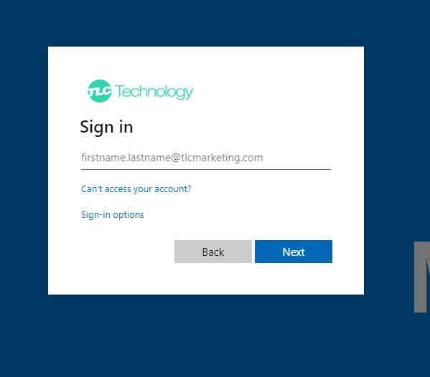

At code level to Authorize the access to the portal or specific areas of the platform we use the Taas Identity service.

The Identity Service will check if the account is Authorized, if it is authorized for a specific market and campaign and will check the roles authorization as well.

Taas Identity service is developed starting from the Microsoft Identity service library and so we can use AAD, however, it is import that we keep updated the code because if Microsoft will apply changes to their Identity library and this can make weaker our security process.

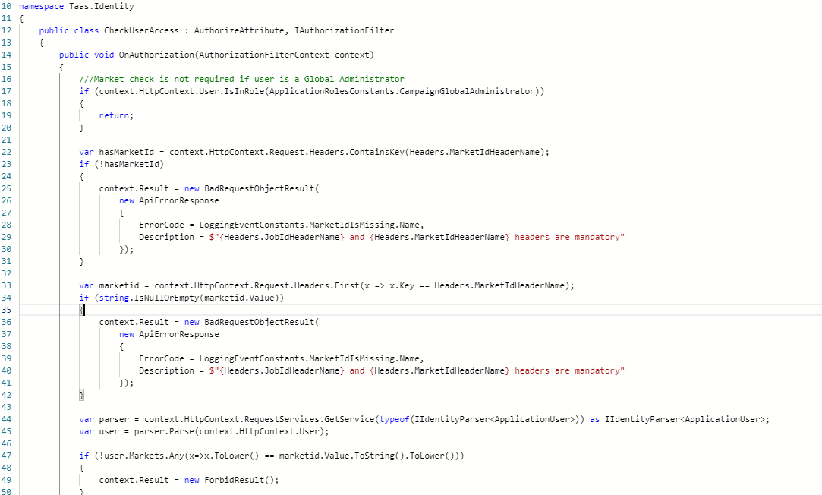

All those informations are present in both: back-end and front-end.

In the back-end, before accessing any call to the Content Management Service there is the Identity check based on the role that will check if a CampaignAdministrator has access to that campaign, and will give all the access to the CampaignGlobalAdminitrator, so he will be able to edit all the metadata that can be modified.

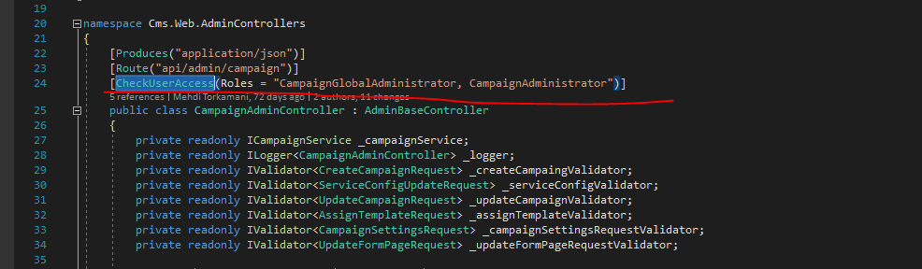

On the client-side, the different AdminStateService will manage the level of access to give to an account with a specific role.

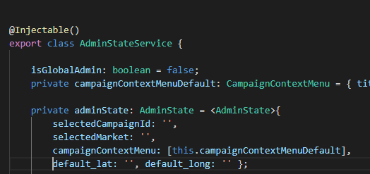

The access to the information is given of if the security check is passed.

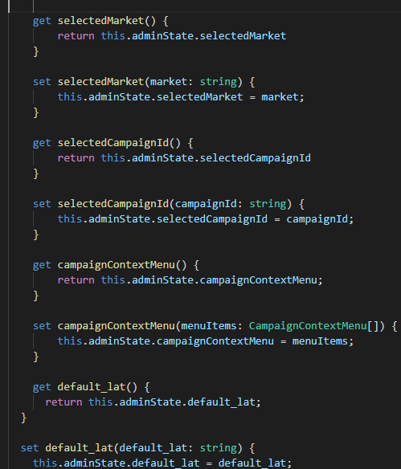

The profile cache is resettled on sign of to avoid cache problems.

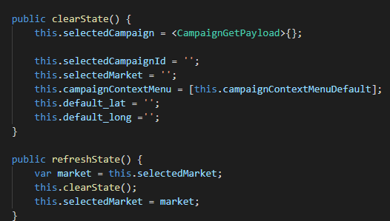

All the information about an account is transported by a Bear Token that is encrypted and can be used only for a few minutes before it expires.

Here the part of the decrypted Bear Token on JWT.io 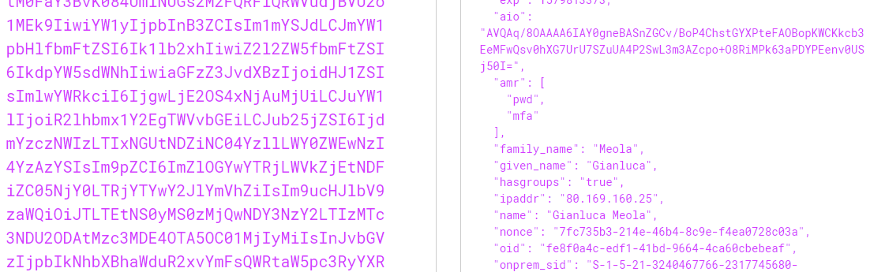

# **Development Support**

applies industry standard approaches for configuration management and version control to manage code during build and release.

**Work activities demonstrating the minimum expected level of competence (Pass)**

* Uses established techniques as directed to identify current problems and elicit, analyse, specify and document business functional, data and non-functional requirements for simple subject areas with clearly defined boundaries.
* Takes part in client/user meetings and assists in presenting issues and solutions both orally and in writing.
* Assists with software builds, for loading onto target hardware, from software source code (typically held within a configuration management system).
* Assists in the configuration of software and equipment for the systems testing of platform-specific versions of one or more software products.

**Work activities demonstrating competence beyond the minimum expected (Merit/Distinction)**

* Selects appropriate techniques for the elicitation of detailed requirements taking into account the nature of the required changes, established practice and the characteristics and culture of those providing the requirements.
* Analyses, specifies and documents business requirements as directed, ensuring traceability back to source. Analyses them for adherence to business
* objectives and for consistency, challenging positively as appropriate.
* Arranges, prepares and facilitates client/user meetings and presents issues and solutions both orally and in writing.
* Produces software builds, for loading onto target hardware, from software source code (typically held within a configuration management system).
* Participates in the configuration of software and test equipment for systems testing of platform-specific versions of one or more software products with minimum supervision.

# **Data**

makes simple connections between code and defined data sources as specified.

**Work activities demonstrating the minimum expected level of competence: (Pass)**

* Creates and amends simple programs in accordance with the design.
* Within a project environment, assists in the investigation of application data and process requirements, documenting them according to the required standards, utilising the prescribed methods and tools.
* Produces components of detailed designs, such as: physical data flows, class diagrams, file layouts, common routines and utilities, program specifications or prototypes, and backup, recovery and restart procedures.
* Documents all work using required standards, methods and tools, including prototyping tools where appropriate.

**Work activities demonstrating competence beyond the minimum expected: (Merit/Distinction)**

* Creates, amends and keeps track of moderately complex programs in accordance with the design.
* Within a project environment, applies data analysis and data modelling techniques, based upon a general understanding of the business process, to establish, modify or maintain a data structure and its associated components (e.g. entity descriptions, relationship descriptions, attribute definitions).
* Produces detailed designs including for example: physical data flows, class diagrams, file layouts, common routines and utilities, program specifications or prototypes, and backup, recovery and restart procedures.
* Documents all work using required standards, methods and tools, including prototyping tools where appropriate.

The Project that my colleague and I are working on uses the Cosmos DB database. Cosmos DB is Microsoft’s highly scalable, NoSQL database platform running in Azure. Cosmos DB stores "items" in "containers". Items can be queried with a read-only, JSON-friendly SQL dialect.

We use Cosmos DB to save the forms submissions, to store the metadata save from the CMS platform to populate the Client SPA and for the Client SPA Mechanics feature.

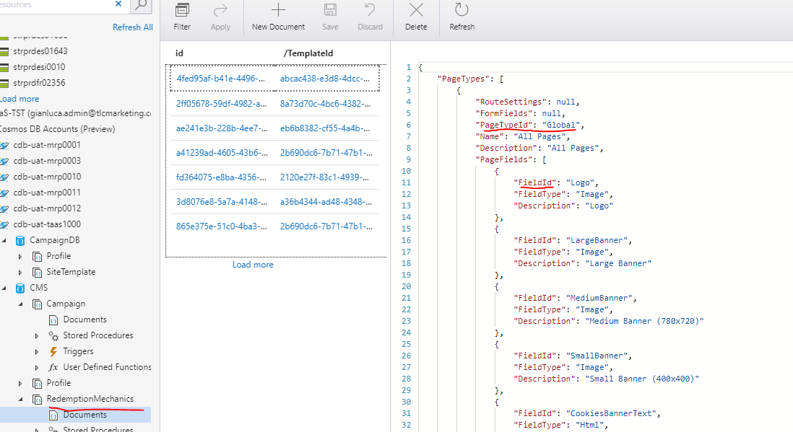

About the Mechanics feature is a single JSON file that is different for different customer journeys. This file is in charge to tell the front-end web application which fields are available for the metadata and which services should be "ON" for this customer journey.

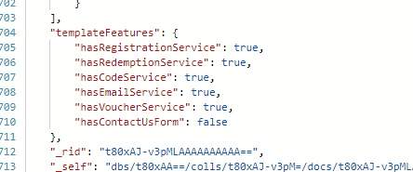

And how at code (high) level I retrieve if the services are used for this customer journey.

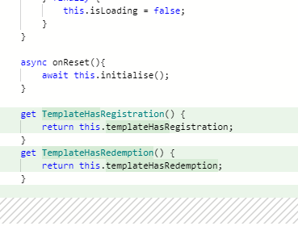

The metadata file is the one that I use most and I edited most during my period at TLC Marketing. The metadata is saved from the CMS platform and bind in the web app application.

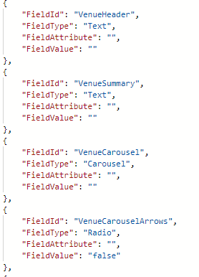



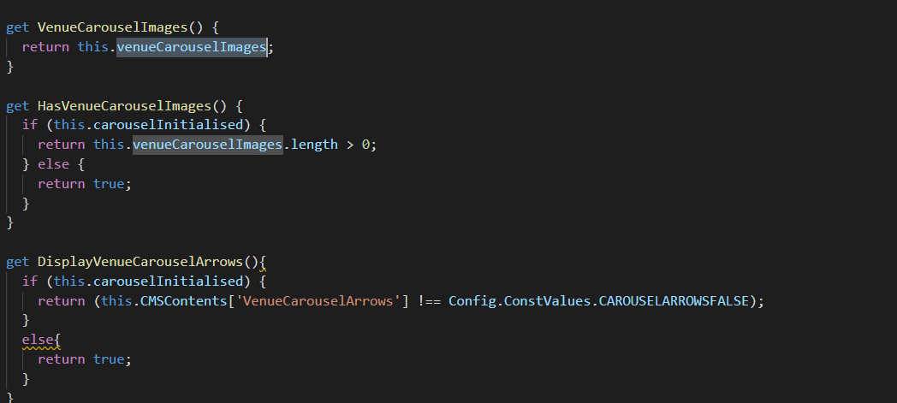

Html bind.

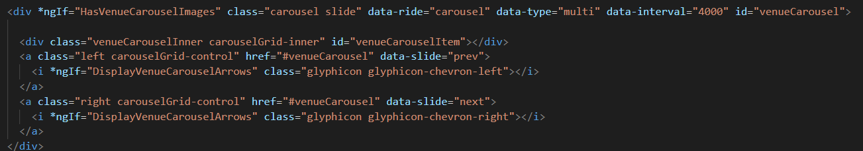

To retrieve the content that I need in from Cosmos DB I created a content service on the Angular Client application, that communicate with the CMS service (technical debt nr1: poor name choice made head from previous back-end developers, should be changed to Content Service) that will query the database searching for 3 variables (technical debt nr2: again poor choice made head but is necessary to use both now, should be used just two variables: JobId and MarketId ).

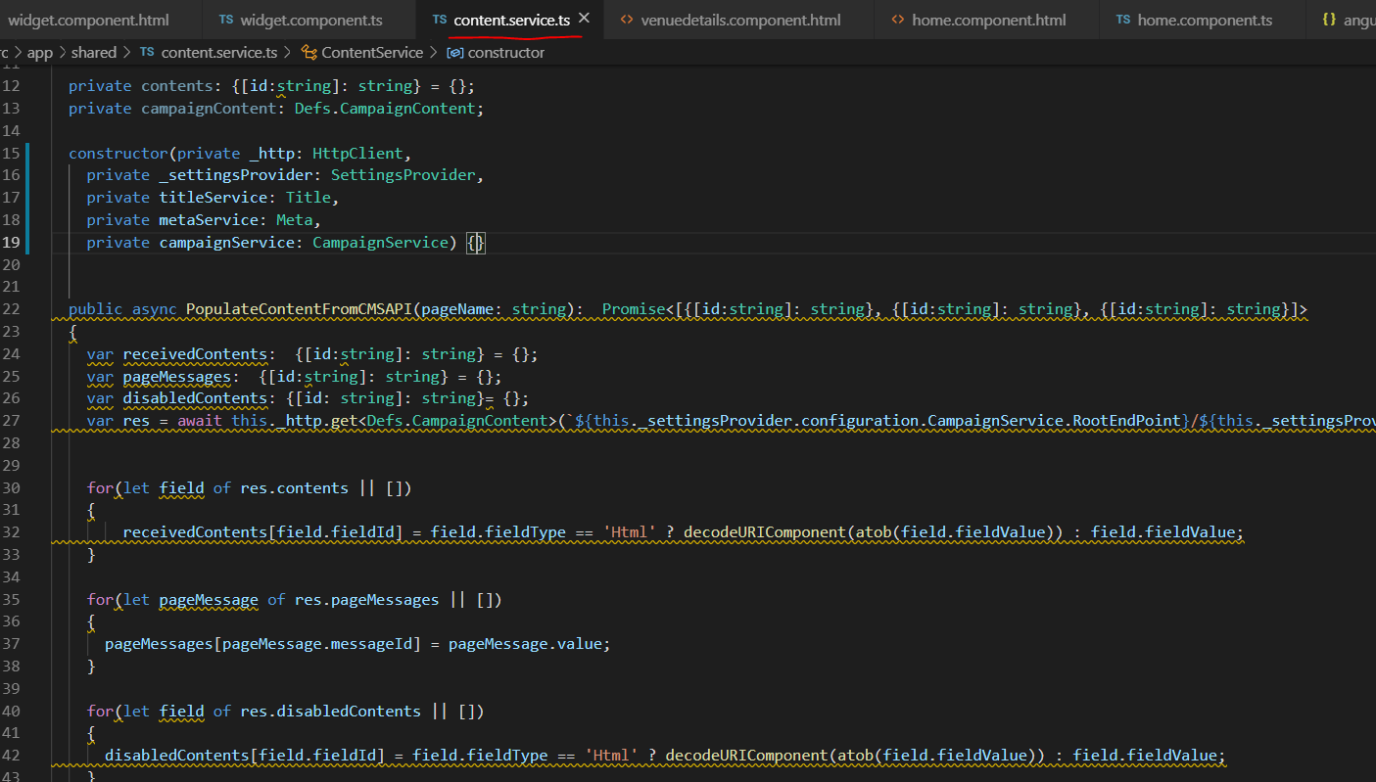

Each page through the Content Service will populate the fields that the client chooses to populate.

This is a part of the code used to create the registration form dynamically from the metadata: 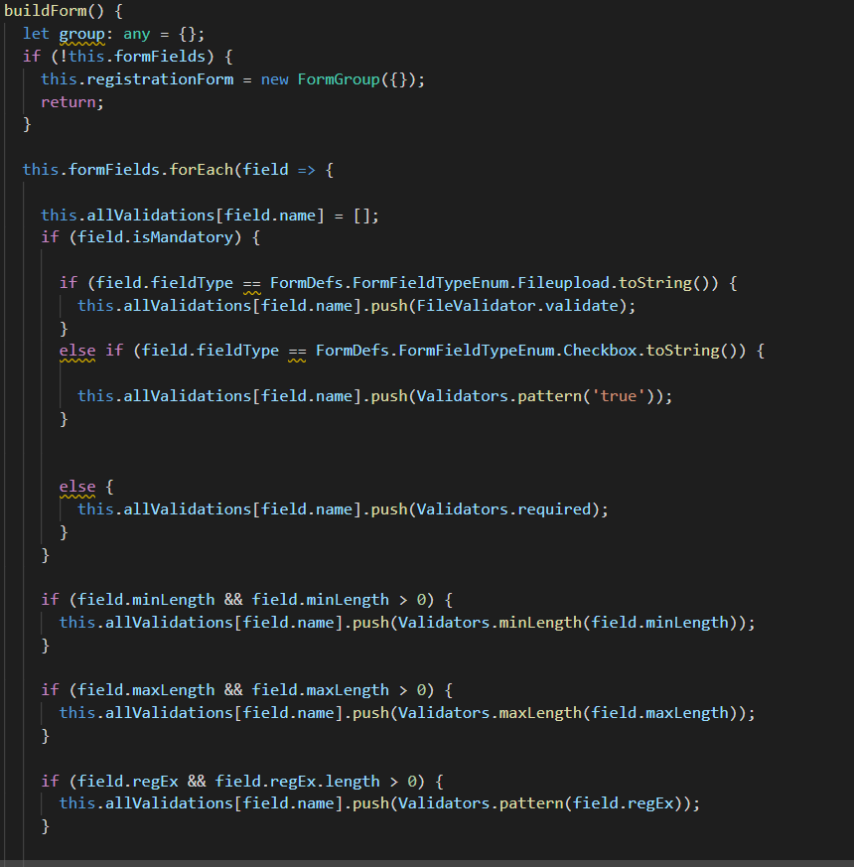

On Cosmos DB we store the submission as well, and each submission is a file in Cosmos.

Here I reported the function that send the content for the registration to the Registration Service to save it in the Cosmos DB. The fields are saved as string, to so we can dynamically handle them when we must create the reports.

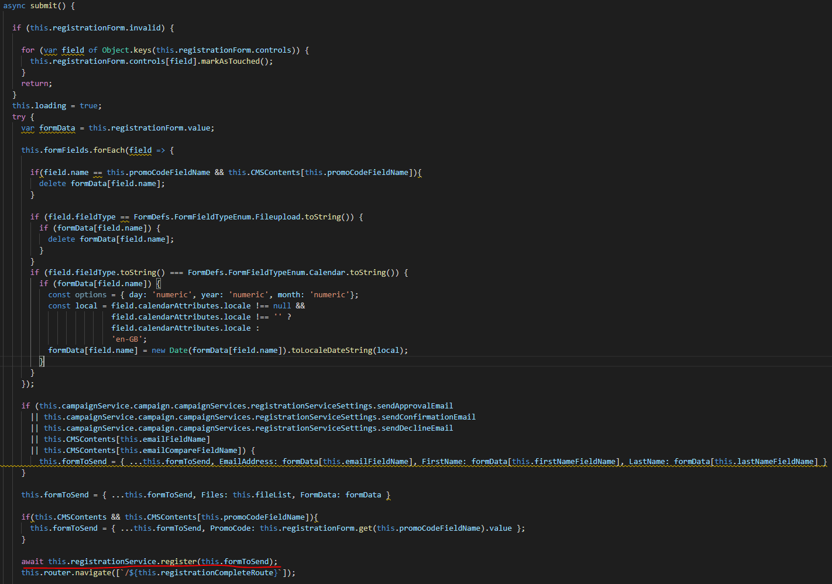

In the Array inside the object the fields are saved dynamically.

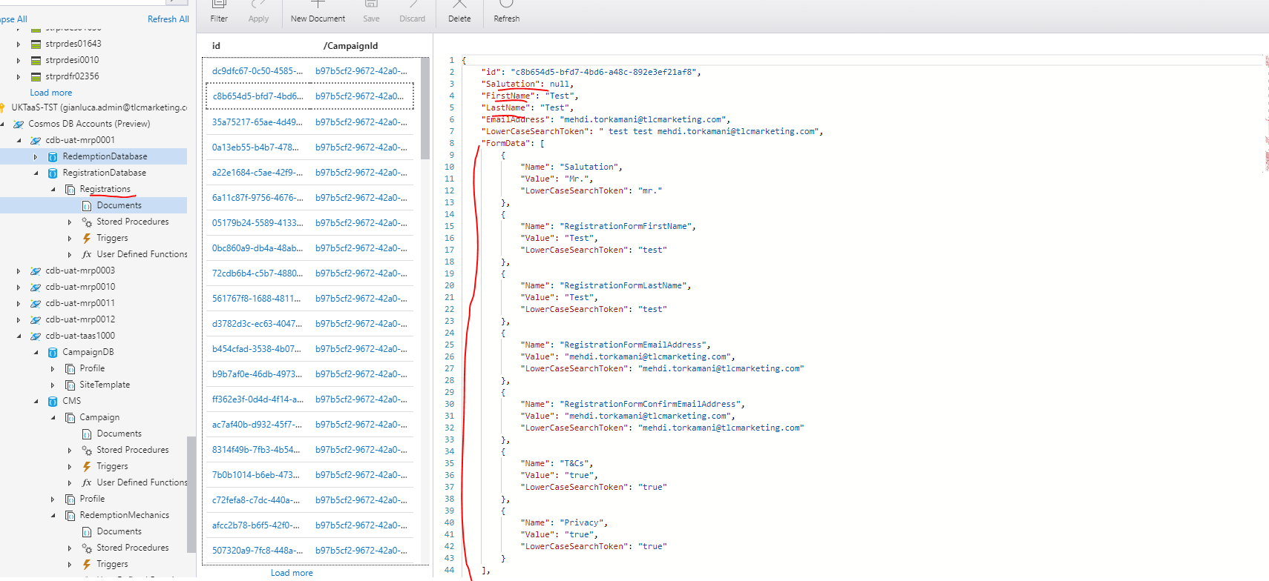

Then I create the report for each campaign, using PowerBI and DAX language to perform the Query:

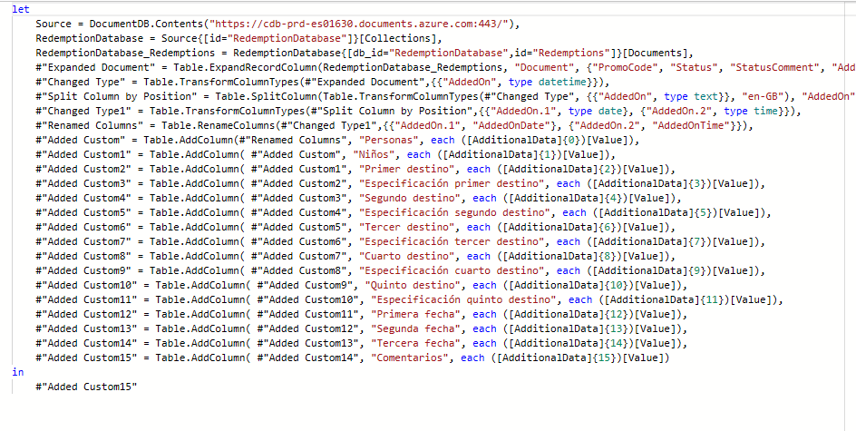

To notice that the “AdditionalData” is the array of Dynamic fields created, that I map to create the report. In this way the client can add as many extra fields he needs.

# **Test**

Apprenticescan functionally test that the deliverables have/have not been met.

**Work activities demonstrating the minimum expected level of competence: (Pass)**

* Plans, designs and conducts tests of simple programs; corrects errors and retests to achieve an error-free result.
* Defines test conditions for given requirements.
* Designs test cases and creates test scripts and supporting data, working to the specifications provided. Understands techniques for prioritising tests (e.g. based upon risk or the area of change). Optimises value of testing within limited time-boxes.
* Interprets and executes supplied sets of simple test scripts using agreed methods and standards, in accordance with project test plans.
* Checks test results, and documents test failures and successes compared with pre-determined criteria.
* Analyses and reports test activities and results to supervisor and/or other colleagues in a clear and concise manner.

**Work activities demonstrating competence beyond the minimum expected: (Merit/Distinction)**

* Plans, designs and conducts tests of moderately complex programs; corrects errors and re-tests to achieve an error free result.
* Reviews requirements and specifications and defines test conditions.
* Analyses test requirements, designs and builds simple test-case suites, test scripts, and test procedures, with expected results.
* Interprets and executes sets of moderately complex test scripts using agreed methods and standards, recording and reporting outcomes.
* Checks test results, and documents test failures and successes compared with pre-determined criteria, in accordance with agreed standards.
* Analyses and reports test results to supervisor and/or other colleagues in a clear and concise manner. Identifies and reports issues and risks associated with own work.

Unfortunately, at work, I do not use often TDD or BDD, because of business needs. I do not have a working test code to check if is everything working. Then to check if is everything working and there are no errors, I must create a script for a manual test.

Through the analysis of the newly implemented code and the required new functionalities acceptance criteria, I can design a proper step-to-step script to test if the code is working properly and did not break anything that just exists and was working properly (in particular when there are modifications to the Model that often have to be implemented in multiple Microservices).

In this period, I created a new form for the front end, where the users can contact the Support Team.

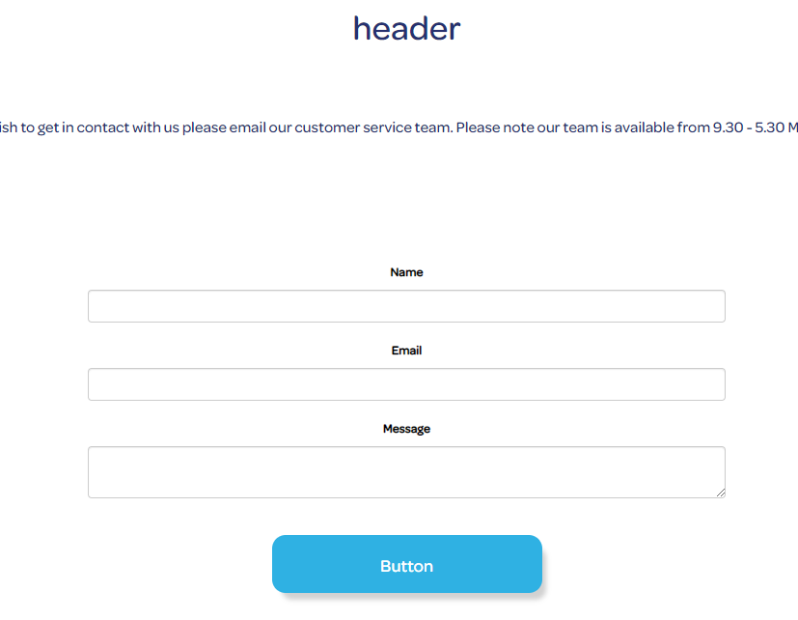

For this form, all the fields must be mandatory.

However, if the email field does not have a validation pattern, can create problem and the customer can enter an incorrect email address. Then the email field needs to be validated, if not the code has to display the error and tell the user where the problem is.

As we can see for the three fields name, email and body I added validators to make them mandatory and for email I added a pattern validator to check if the syntax for the email is valid.

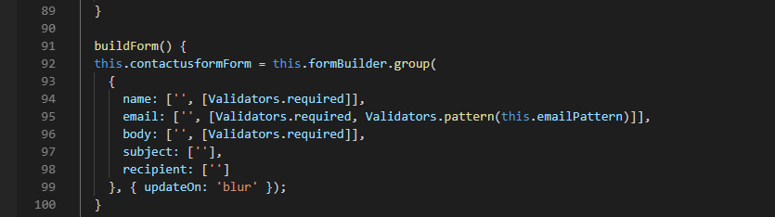

To test if the form is working properly I reproduced the normal customer journey and check whether can goes wrong: for example if any of the fields are left empty and I submit the form if the error messages are displayed or if even the error messages are displayed or if I enter a wrong pattern for the email if the “invalid format” message is displayed.

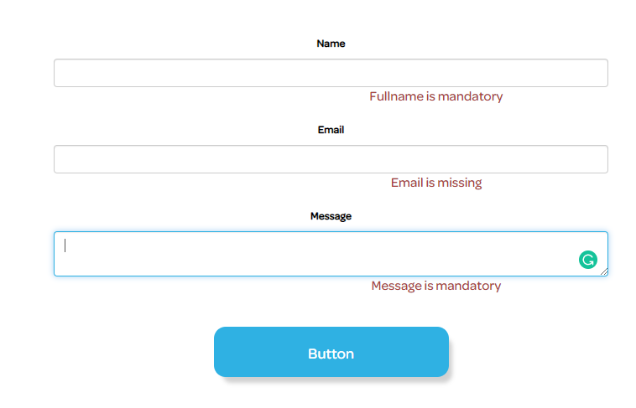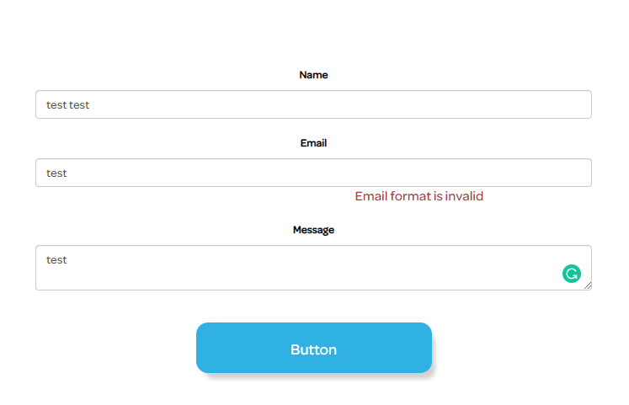

The next test is to check if we submit the correct form if the post method.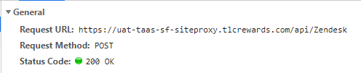

And then I check if the “Payload” is sent in the correct way and all the fields are rigth.

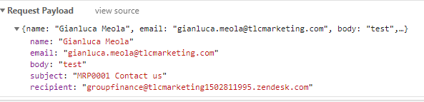

And then finally I check if the success page is loaded and display all the information needed, like ticket number and customer name.

And I do a final check if I received the support email to be sure the ticket has been created on the Zendesk portal.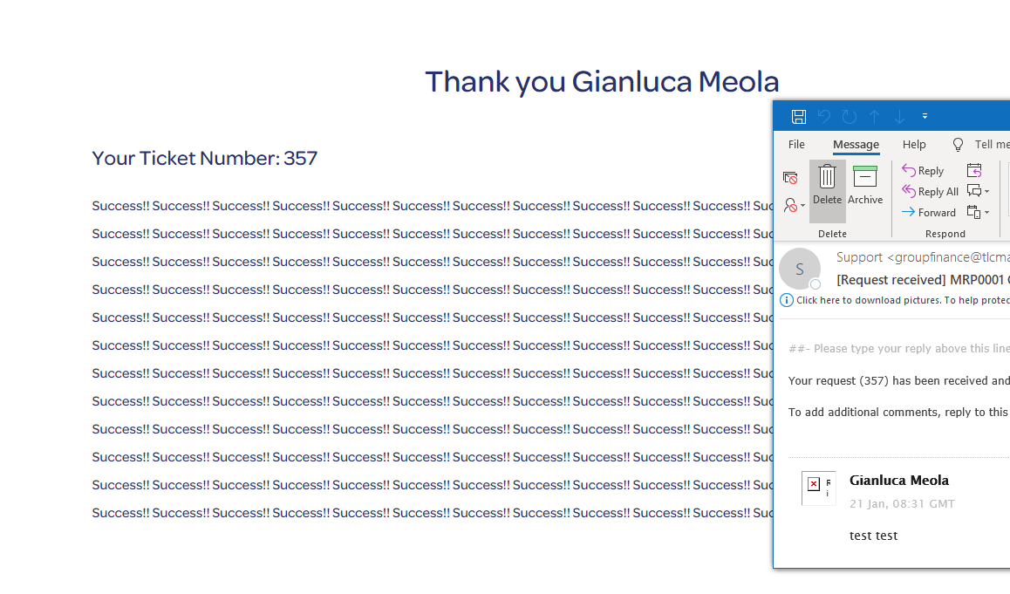

It seems to work everything fine, however often the clients leave some fields empty on the platform because they think that those fields are not needed. For example, in this case, if the subject of the form is empty the backend will throw an error: 400 Bad Request.

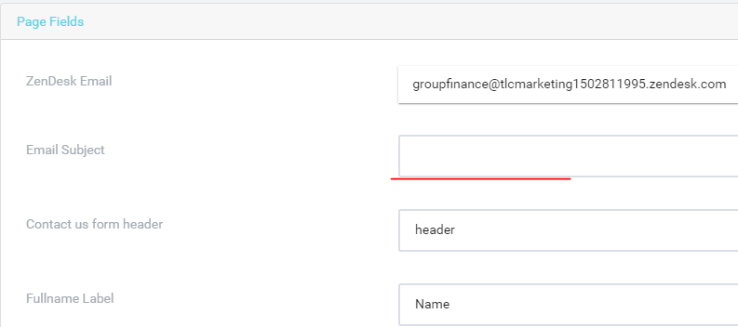 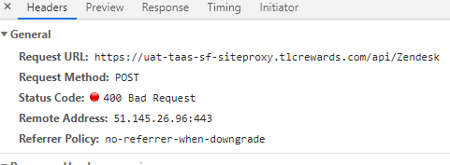

Fortunately, in this case, the back-end handles the error and it is easy to identify the problem. 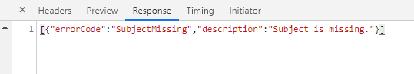

Then the solution that I choose is to give a default value ( "Job number" + "contact form") if the field is empty.

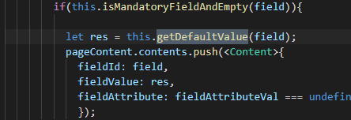 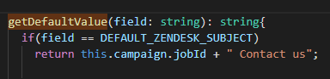

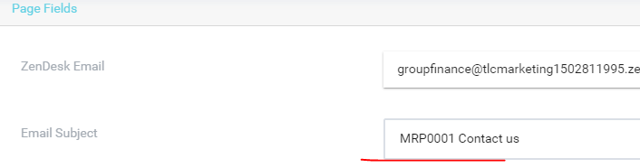

# **Analysis**

Apprentices follows basic analysis models such as use cases and process maps.

**Work activities demonstrating the minimum expected level of competence: (Pass)**

* Assists colleagues and clients/users to investigate and model business functions, processes, information flows and data structures, using various methodical and consistent techniques.
* Assists colleagues and clients/users in specifying information flows, processes/procedures and data objects that align with the needs of the business.
* Takes part in client/user meetings and assists in presenting issues and solutions both orally and in writing.
* Records work with appropriate documentation, meeting the required standards, and uses suitable methods and tools.

**Work activities demonstrating competence beyond the minimum expected: (Merit/Distinction)**

* Works with colleagues and clients/users to investigate and model business functions, processes, information flows and data structures, using various methodical and consistent techniques.
* Works with colleagues and clients/users in specifying information flows, processes/procedures and data objects that will meet the business requirements.
* Arranges, prepares and facilitates client/user meetings and presents issues and solutions both orally and in writing.
* Records work with appropriate documentation, meeting the required standards, and uses suitable methods and tools.
* Understands the purpose and benefits of modelling, and uses established techniques as directed to model simple subject areas with clearly defined boundaries.
* Elicits and records business/context rules and concepts, and confirms them with business experts.

In this project I will create a site Generator to add to the existing system of Microservices the are in Taas (the Tlc Marketing back-end architecture system). The client required to be able to duplicate the microservice just with a click, here there is all the workflow of the project.

The solution layout, that tell us that what I’m building is a microservice. There are different projects connected to the services, that is where the logic act, the Model, 2 UI interface The Shell and the web application (still work in progress). To notice that I am using a MockAPI to simulate the return of the data that the program needs.

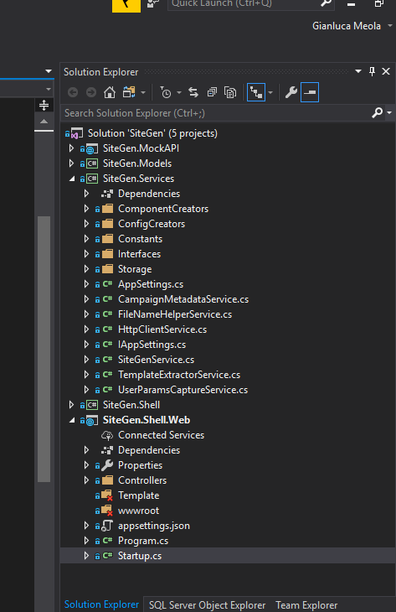

In the Startup.cs I declare all the services with a brief description, to say that this method adds the services in the container.

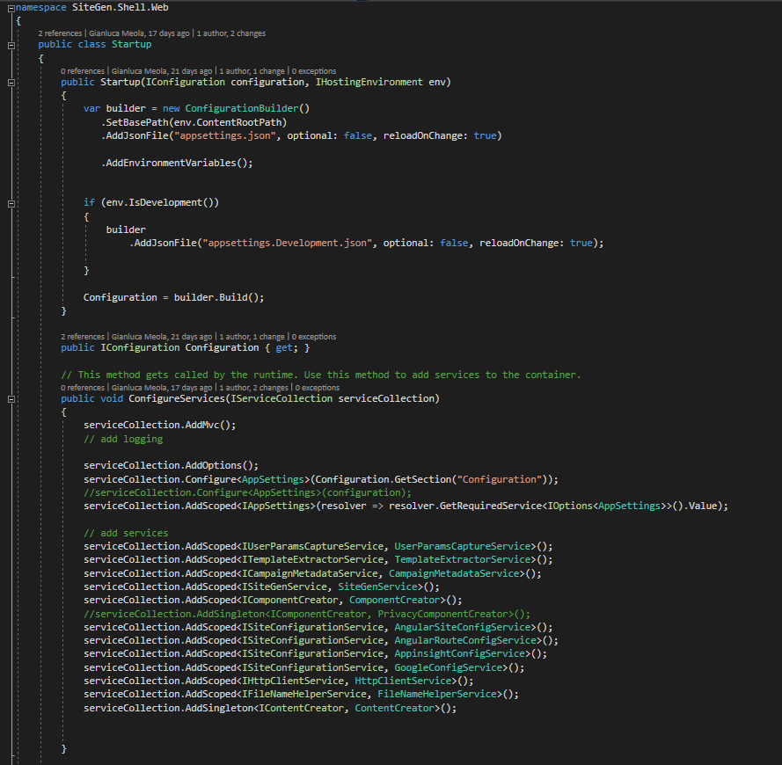

Then after that, I defined the services that just exist that I will use, I created a concept mat to organize all the logic of the program that must generate the website and the metadata. Is the metadata that have to be read form the database (CosmosDB) and in the Storage (Azure Blob Storage) a JSON file must be created.

In the next page there is the flow that I plan to follow for the development of the app.

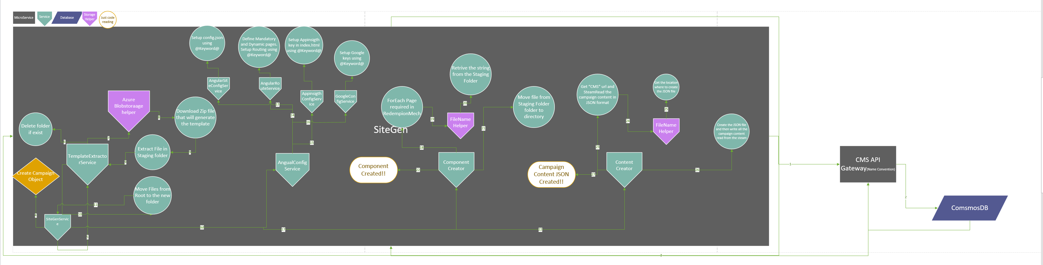

Once that the API is called the SiteGen Service will call the CMS API (in the API that I’m working on the local machine is calling the Mock API) to gather the data to create The Campaign object. The campaign object has all the information to create the new microsite.

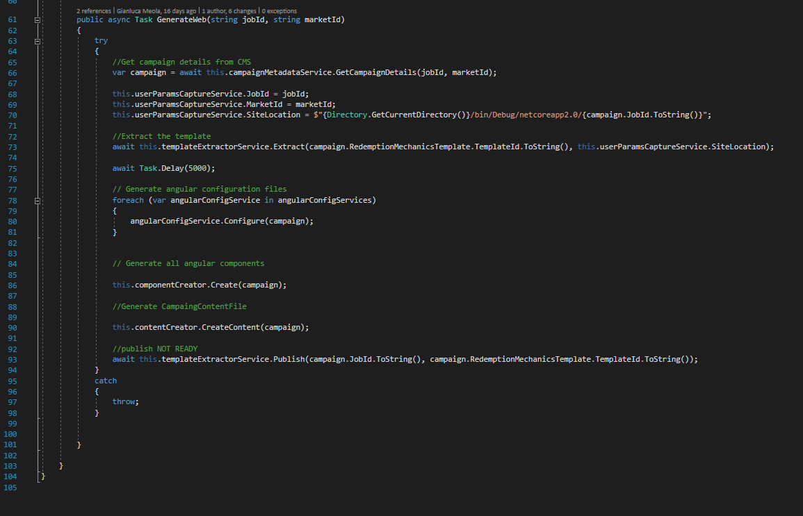

TemplateId that will create the right path to gather the zip file.

The TemplateExtractorService will download the SPA (Single Page Application) from the Azure Blob Storage and extract the file (for the local machine version) inside the bin folder. And will move the root folder in a folder with the JobId name.

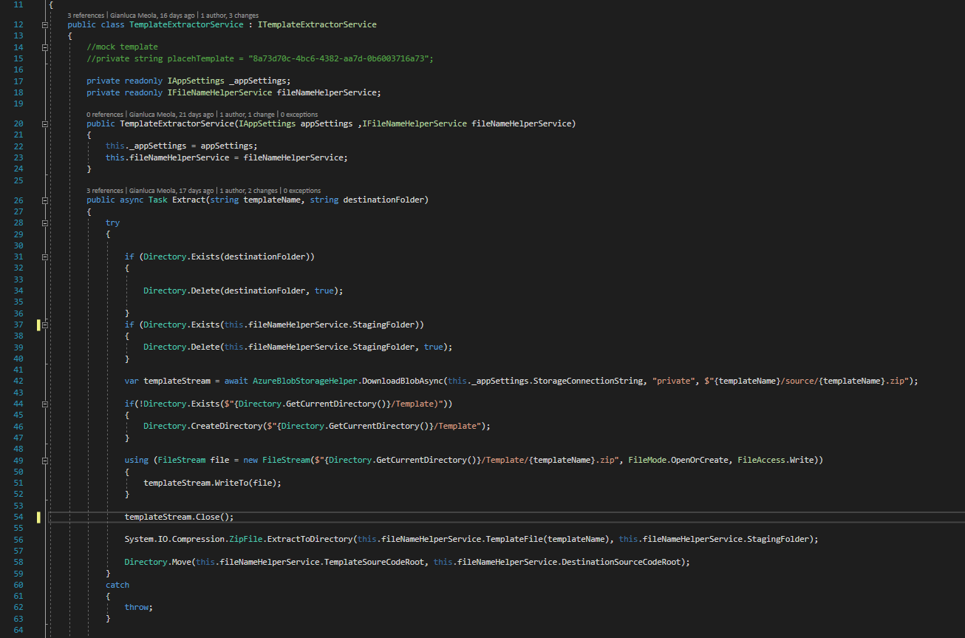

The AngularConfigurationService will print in the SPA the variable specific for the campaign, like the Angular component that the campaign need (registration or code), or the Goole API keys

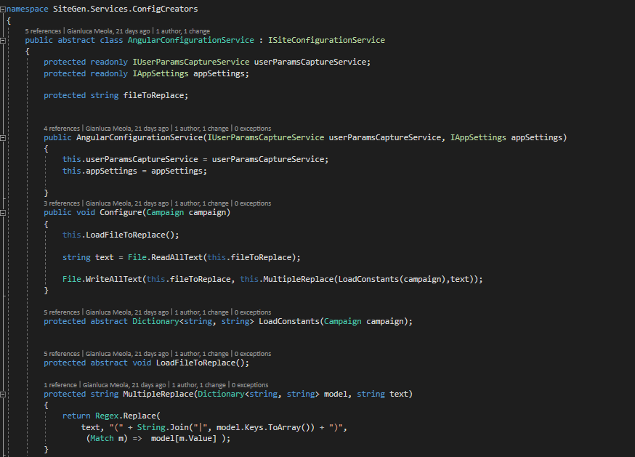

The component creator will select and copy the Angular component needed in the new SPA and will inject them one by one.

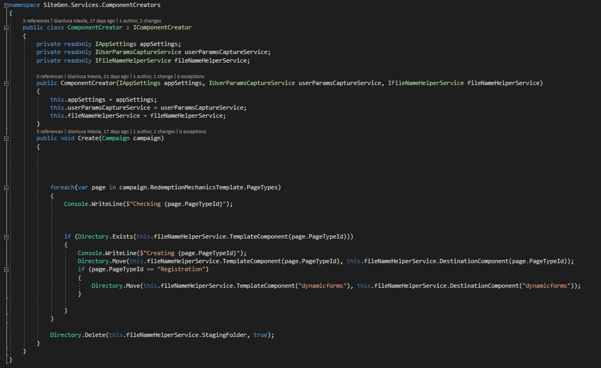

The content Creator will call the CMS again to get all the metadata from the database and will create a JSON file in the Assets of the SPA so the Spa will not have to call the CMS to get the metadata to populate the microsite.

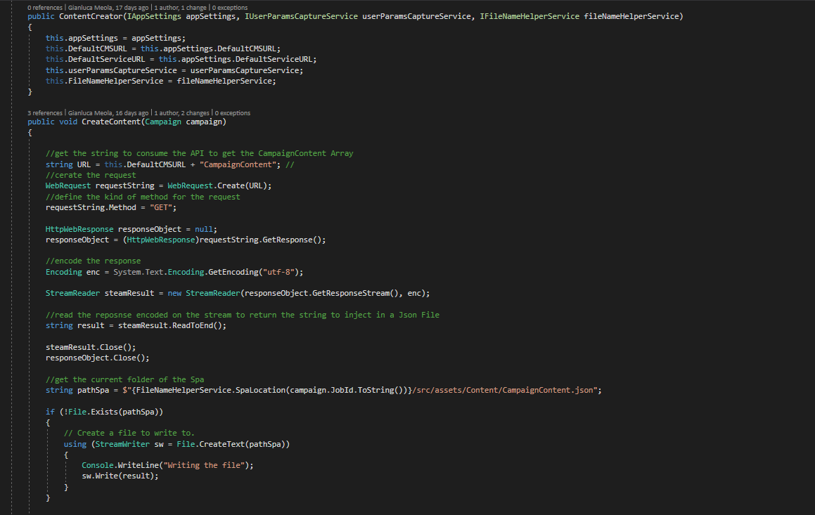

Inside the SPA I changed the API call to populate the microsite so it will read straight from the JSON file.



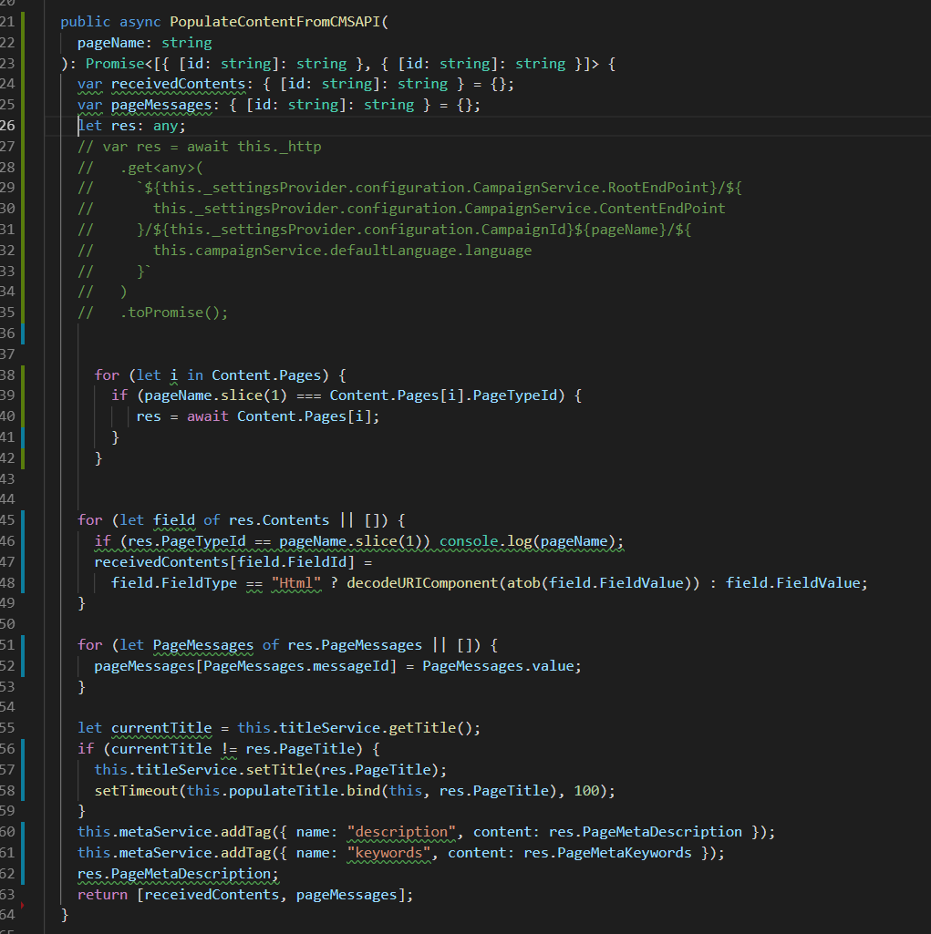

**Development Life Cycle**

supports the software developers at the build and test stages of the software development life cycle.

**Work activities demonstrating the minimum expected level of competence: (Pass)**

* Takes part in reviews of supplied specifications.
* Takes part in reviews of own work.
* Identifies and reports issues and risks.
* Assists other members of the software development team in improving software functionality and performance by discussing test results.

**Work activities demonstrating competence beyond the minimum expected: (Merit/Distinction)**

* Conducts reviews of supplied specifications with others, as appropriate.
* Takes part in reviews of own work. Takes part in reviews of the work of colleagues.
* Records explicit details of failing test cases, such that delivery teams can understand and reproduce issues found.
* Provides guidance and assistance to colleagues in any aspect of program design, creation, testing, documentation, debugging and maintenance.

From when I started to work as part of a team, I learned the importance to have a good organization to work together for a common goal to achieve. What I learned is that the goals do not have to be too far, all the team will be motivated to finish the task. Of course, a bigger picture is needed to design a proper path for the development of the application/platform.

Then at work, we follow the Agile development life cycle. We have sprint 2-week length, where we must achieve our goal that is to add a new feature or a bug fix on the platform. Each of the developers will work often on different tasks or sometimes happen that the development team must work on the same feature but at different levels. Often, I work in parallel with the back-end developer to "prepare" the UI interface before that the back-end is finished. Of course, this means that teamwork is important in this case and communication is the key. The positive effects of this kind approach are that we share our knowledge, along the whole development of the project, and working together each of us will do some code review.

Of course, pair programming and code review is not the same thing, because of that before each deployment or commit we ask and give each other a code review from the smaller task to the more complex tasks.

This is important in the environment where I work because of 2 reasons:

* first, because we do not write any test code, then we are not sure that what we are going to deploy is really working properly;
* second, because 2 out of 3 developers are Junior developers and we could have missed something.

In the images below some of the commits with the code review between me and my colleague, where we “force” each other to improve our code.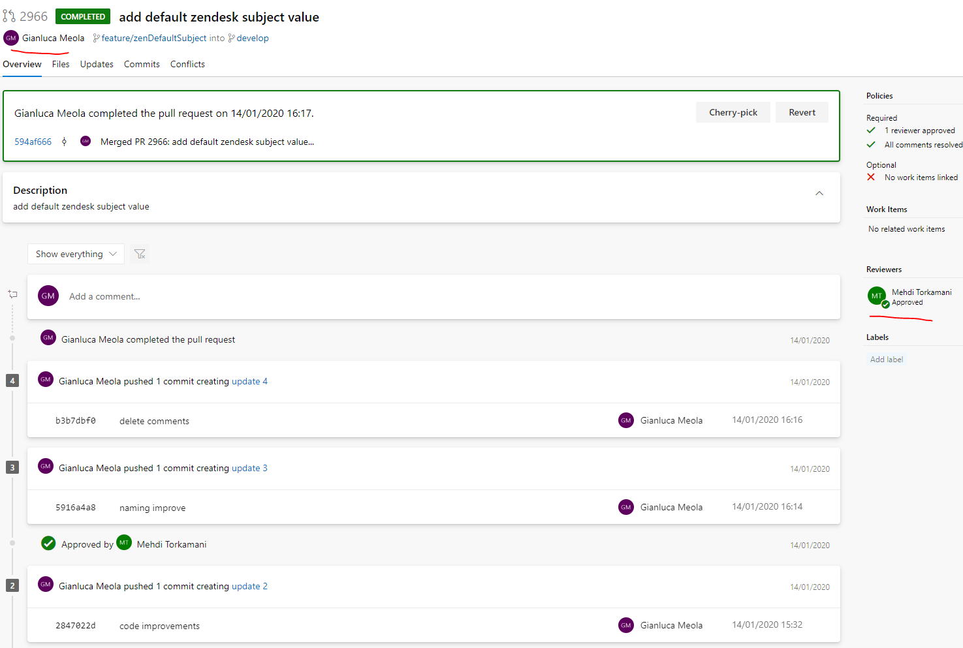

I leaned to work in abstraction too, for example in December, because there was no task left for me on the product backlog, I started to work on a front-end task where the back-end was not even designed.

The task was to create a contact us form for the front-end websites that through an API call will create a ticket on the Zendesk platform (* a ticketing platform for the support team).

I designed the whole code at a very high level of abstraction because there were no specifics, I just knew that I had to send a name, an email and a message.

I followed the good practice principles to give names to the variables to the function and the new object that I created.

Then the first phase was finished, and the form was working locally, I just added some endpoint to mock the API call and then I just left the project, waiting for more details.

When the back-end was completed, after 1 month that I finished my part of the project, I was even surprised that the endpoint was already working and all the variable had the same name of the backend, then to make work the whole form I did not change anything, it was already good to go.

From the image below is clear that I worked on the project just in December and then in January I just added some front-end issue and changed the endpoint string for the Zendesk service.

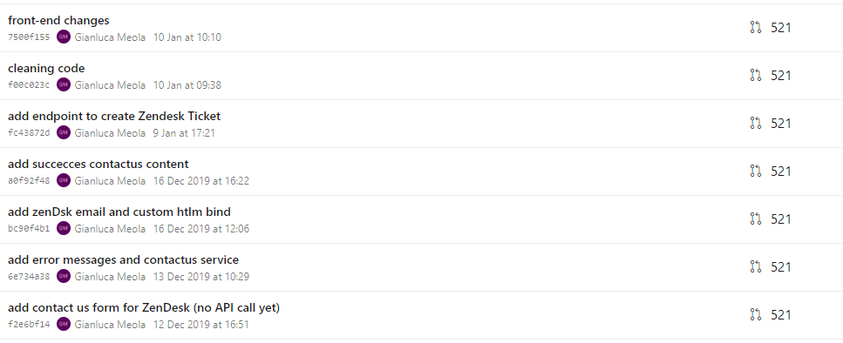

# **Quality**

follows organisational and industry good coding practices (including for naming, commenting, etc.).

**Work activities demonstrating the minimum expected level of competence: (Pass)**

* Designs simple programs and program modifications from supplied
* specifications, using agreed standards and tools, to achieve a well-engineered result.
* Documents all work in accordance with agreed standards.
* Takes part in reviews of supplied specifications.
* Takes part in reviews of own work.

**Work activities demonstrating competence beyond the minimum expected: (Merit/Distinction)**

* Designs moderately complex programs and program modifications from supplied specifications, using agreed standards and tools, to achieve a well-engineered result.
* Documents all work in accordance with agreed standards.
* Conducts reviews of supplied specifications with others, as appropriate.
* Takes part in reviews of own work. Takes part in reviews of the work of colleagues.

The quality of the code is important, whether will be a Junior or a Senior to read the code. Bad code slows down drastically the productivity because you do not understand what you are reding.

The code should be easy to read and understand. To do that there are different practices to follow that will help you to deliver a decent code. Readability will be the key to create a code that can be maintained. If I cannot read the code, I cannot modify it.

The first thing to do is to choose meaningful names for variables, functions, classes, etc. If I use "c" as a variable to store content, I'm sure that I will not remember it tomorrow what that "c" is doing. As well is important to don't have duplicate variables, like "PageContent1" and "PageContent2", because is clear that are page content, but which one is the difference between the two variables?

Another good practice is to create functions that make just one thing, in just one level of abstraction, so the function must be short, and not long more than 4 -5 lines max.

In the first case, I will report an example of functional programming, where I use Object-Oriented programming as well, however, the main structure is the gave from the functional programming in Agular.

I will report here one of the functions that I simplified; it was not complex but was doing many things at different levels of abstractions (take a minute please to read the original function):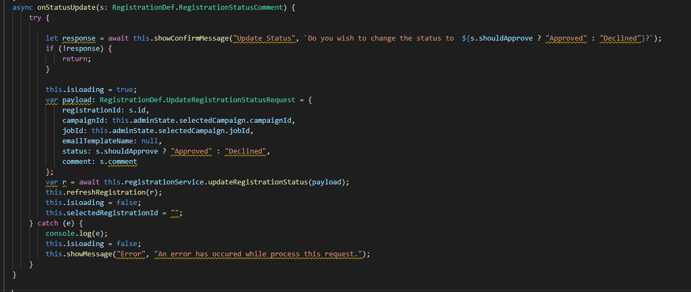

As we can see the function violate the good quality principles different times:

* the function does not use meaningful names ("s" and "r"), and it will take time to understand what those variables contains.
* the function does more than one thing because there are different levels of abstraction in it.
* the function is long, because it does multiples things.

In the image below, I refactored the function, make it shorter and to reduce it at just one level of abstraction. Now the function is easy to read and understand what is doing at a high level. I assigned a new variables name to "s" = "statusComment", in this way the name is more descriptive. I wrapped all the action in the other function at a lower level of abstraction called "changeRegistrationStatus", that I extracted to make the code easier to read, at the high level, I do not need to know in detail what the function does, I have just to understand what is going on.

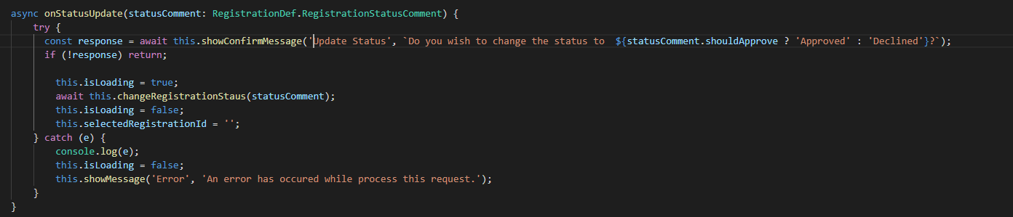

The function "changeRegistrationStatus" change the status of the registration: first, call a lower-level function "preparePayload" to prepare the object to be sent, and then send a request to the back-end with an async call. I choose to extract the object preparation from this function because is clearly a lower level of abstraction and would create just confusion.

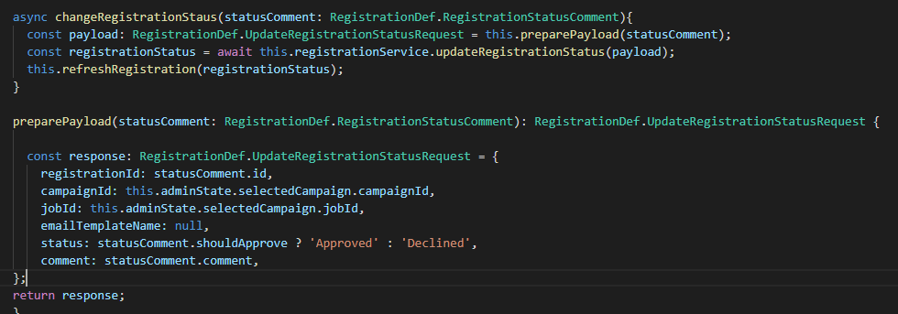

The other example of how it improved the code at a higher level is when I had the task to change the content of the images section modal. I notice that the same logic was used for a similar modal in the Emails and the Vouchers section of the Portal. There was duplicate code, that I could eliminate and merge everything in one component. However, the situation was quite worse than tough: the HTML code was encrypted and injected in the angular component:

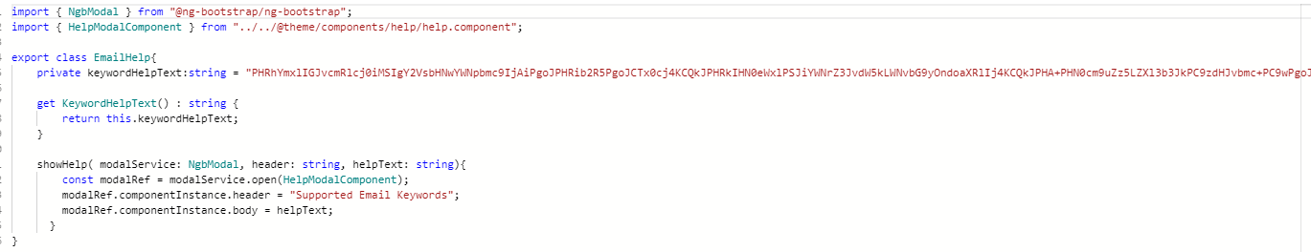

I am not able to take the screen shot of the entire string, but it is very long.

After that I fixed that problem converting HTML encrypted in normal HTML, I proceeded to create just one component that could be used from the Emails, Vouchers and the Images page with different content bound from a JSON file. This is an example of how much duplicate code I eliminated at a high level:

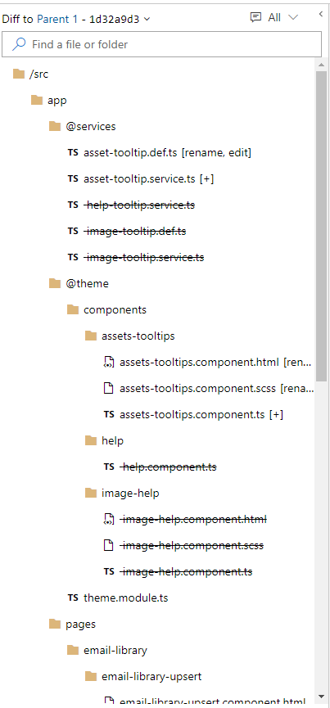 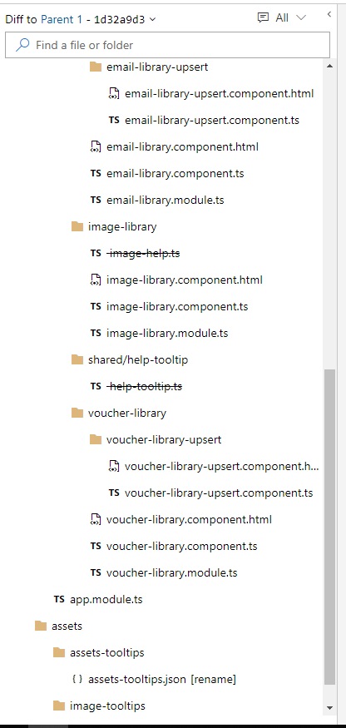

# **Problem Solving**

1. solves logical problems, seeking assistance when required (including appropriate mathematical application);
2. responds to the business environment and business issues related to software development.

**Work activities demonstrating the minimum expected level of competence: (Pass)**

* Plans, designs and conducts tests of simple programs; corrects errors and re-tests to achieve an error free result.
* Within own area of competence investigates issues and other requests for application support and determines appropriate actions to take.
* Within own area of competence and working closely with more senior colleagues, provides correct responses to requests for application support.
* Carries out fault diagnosis relating to simple software failures, reporting the results of the diagnosis in a clear and concise manner.

**Work activities demonstrating competence beyond the minimum expected: (Merit/Distinction)**

* Plans, designs and conducts tests of moderately complex programs; corrects errors and re-tests to achieve an error-free result.
* Within own area of competence, provides correct responses to requests for application support by means of, for example: making modifications to software, developing workarounds, training users or operations staff, producing additional documentation, or escalating requests to colleagues.
* Carries out fault diagnosis relating to moderately complex software problems, reporting the results of such diagnosis in a clear and concise manner.

In the first couple of months that I was working for Tlc, I faced many problems and bugs because the platform was at an early stage and was full of bugs. For me at that time, those problems seem to be bigger than they were. Because of my inexperience and because of my lack of knowledge about the system. Then I had to follow some techniques that helped me to understand better the problems. I used the Drill Down Technique, which is a technique frequently used in business to highlight any process that narrows something down from bigger components into smaller pieces. I used this technique because I was not sure if I was facing a code bug issue or a DevOps issue or something else. Then analysing the problem in smaller pieces, I was able to check if each small piece of coda had bugs or not. Most of the problems are not related to bugs but to the deployment issue or access issue, an area that I do not have access to. I both cases I have to report that to the Head of the Developer when he is in the office that will take care of it, or if the Head of the Development is not in the office: if it is a deployment issue I suppose to report the problem to the DevOps engineer; if it is an access issue I will have to report the problem to the cloud engineer.

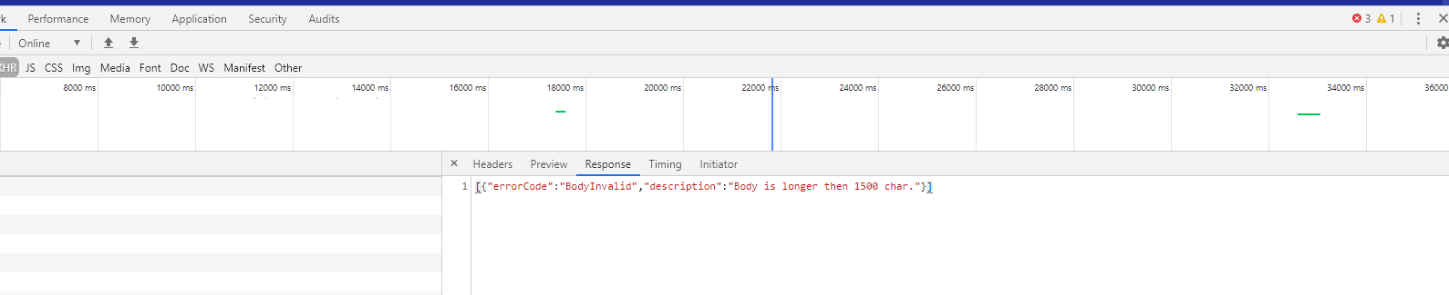

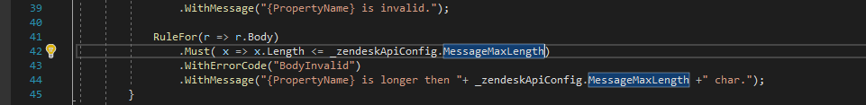

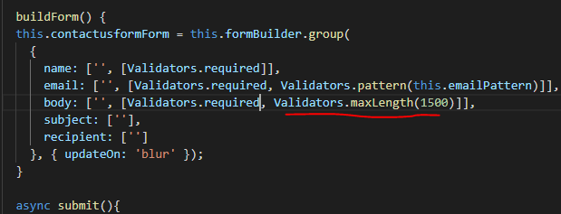

# **Communication**

clearly articulates the role and function of software components to a variety of stakeholders (including end users, supervisors etc.).

**Work activities demonstrating the minimum expected level of competence: (Pass)**

* Takes part in client/user meetings and assists in presenting issues and solutions both orally and in writing.
* Documents all work in accordance with agreed standards.

**Work activities demonstrating competence beyond the minimum expected: (Merit/Distinction)**

* Arranges, prepares and facilitates client/user meetings and presents issues and solutions both orally and in writing.
* Documents all work in accordance with agreed standards.

**CONCLUSION**